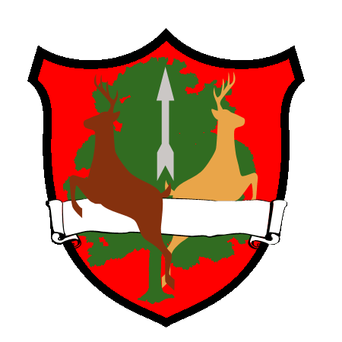
St Giles CE Primary School
2020-2021

Parental consent for local off-site activities/photographs

(Annual consent form).

Dear parent or guardian,
This is a consent form to cover local off-site trips and visits that your child may be undertaking during the school year, and permission for internal/external photographs to be taken and used. These visits may include short journeys on foot or in vehicles and some may continue beyond the school day. Details of each visit will be sent to you in advance. None of these visits includes any adventurous activity, or involves an overnight stay. A separate specific consent form will be sent out for visits involving adventurous activities or for residential visits.

Outline of planned visits

- Visits to the local area
- Day tips enrich the curriculum involving coach transport
- Visits to local schools involving the use of a mini-bus or staff car

Name of child Date of birth

Special details - any information about your child’s health which may need special attention, but does not prevent them from taking part should be noted below. (For example; any allergies, any medication needed and the dosage, travel sickness, diabetes, asthma or epilepsy?)

Has your child had any relevant recent illness?

Does your child have any specific dietary requirements?

Do you have any additional comments?

- I would like my child to take part in the programme of visits planned for the school year. I understand that the arrangements for each visit will be sent to me in advance.
- I consent/I Do not consent to photographs being used for internal publicity and use on the school website/school publicity.

Signature of

parent or guardian

Date

Name of parent or guardian

Address

Telephone number
Home: Work:

